
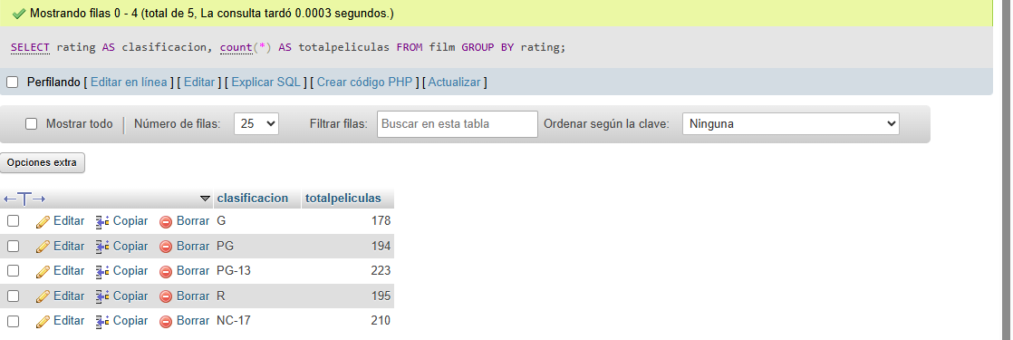
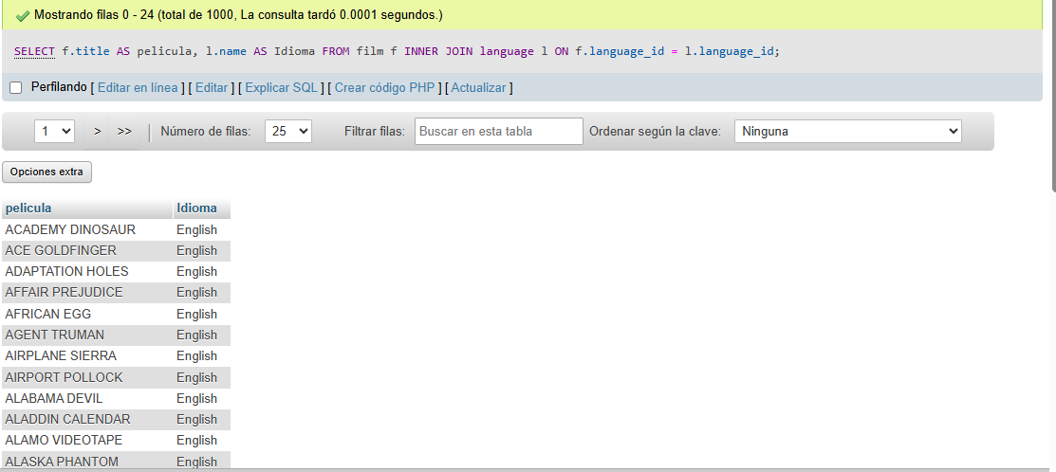

SELECT AVG(length) AS duracion_promedio FROM film;

SELECT title AS pelicula, length AS duracion FROM film WHERE length> (SELECT AVG(length) FROM film);
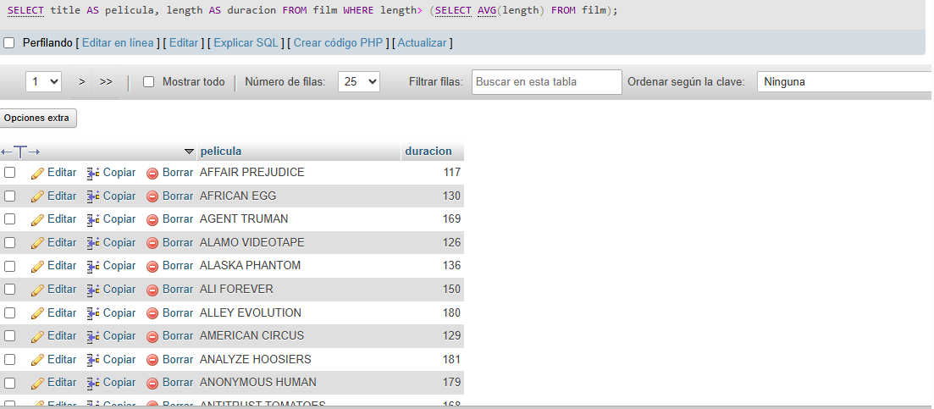

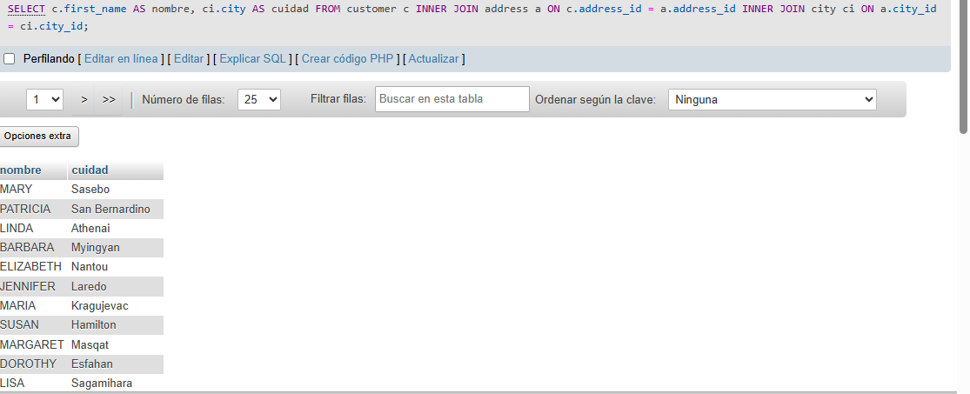
SELECT c.first_name AS nombre, ci.city AS cuidad FROM customer c INNER JOIN address a ON c.address_id = a.address_id INNER JOIN city ci ON a.city_id = ci.city_id;

